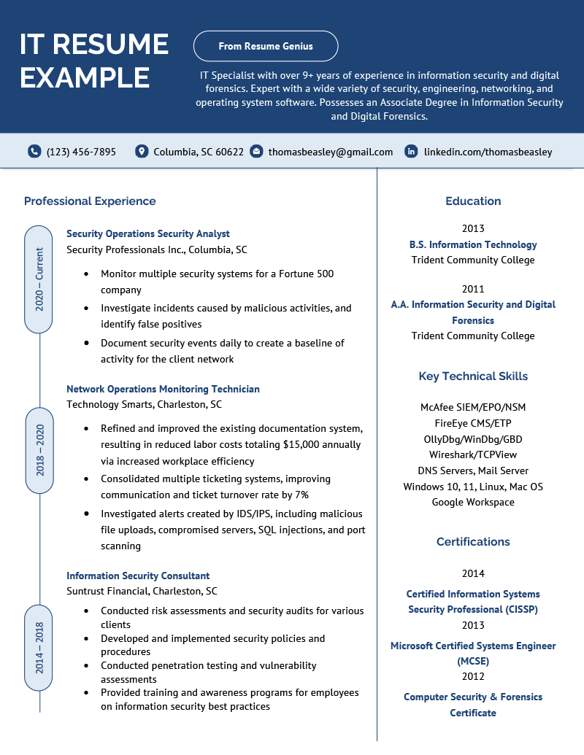
IT RESUME EXAMPLE
From Resume Genius
IT Specialist with over 9+ years of experience in information security and digital forensics. Expert with a wide variety of security, engineering, networking, and operating system software. Possesses an Associate Degree in Information Security and Digital Forensics.
(123) 456-7895
Columbia, SC 60622
thomasbeasley@gmail.com in linkedin.com/thomasbeasley
Professional Experience
2020-Current
2018-2020
2014-2018
Security Operations Security Analyst
Security Professionals Inc., Columbia, SC
• Monitor multiple security systems for a Fortune 500 company
•
Investigate incidents caused by malicious activities, and identify false positives
• Document security events daily to create a baseline of
activity for the client network
Network Operations Monitoring Technician Technology Smarts, Charleston, SC
• Refined and improved the existing documentation system, resulting in reduced labor costs totaling $15,000 annually
via increased workplace efficiency
• Consolidated multiple ticketing systems, improving communication and ticket turnover rate by 7%
• Investigated alerts created by IDS/IPS, including malicious file uploads, compromised servers, SQL injections, and port scanning
Information Security Consultant
Suntrust Financial, Charleston, SC
•
Conducted risk assessments and security audits for various clients
Developed and implemented security policies and procedures
• Conducted penetration testing and vulnerability
•
assessments
Provided training and awareness programs for employees on information security best practices
Education
2013
B.S. Information Technology Trident Community College
2011
A.A. Information Security and Digital
Forensics
Trident Community College
Key Technical Skills
McAfee SIEM/EPO/NSM FireEye CMS/ETP OllyDbg/WinDbg/GBD Wireshark/TCPView
DNS Servers, Mail Server Windows 10, 11, Linux, Mac OS Google Workspace
Certifications
2014
Certified Information Systems Security Professional (CISSP)
2013
Microsoft Certified Systems Engineer
(MCSE) 2012
Computer Security & Forensics Certificate

